|  |
| --- |
| **2. SIGNAL GENERATORS** |

* 1. Introduction – *signal generator, AF & RF oscillators*
  2. Standard signal Generators
  3. AF sine and square wave
  4. Function generator
  5. Pulse and square wave generator
  6. Standard sweep generator
  7. Random noise generator
  8. Arbitrary wave form generator

|  |
| --- |
| **2.1. INTRODUCTION** |

***What is a signal generator?***

🡪 Signal generators provide different types of wave forms such as sine, square, triangular,

pulse, sweep etc. As signal generator generates a variety of wave forms, it is widely used in

applications such as (i) measurement of frequency response, gain and SNR

(ii) electronic trouble shooting and development

(iii) to test and operate different kinds of electronic equipment

(iv) alignment of radio receivers

🡪 The requirements of signal generators are

* 1. the frequency of signal should be known and stable
  2. the amplitude should be controllable from very small to relatively large values
  3. the signal should be distortion free

***What is an Oscillator?***

🡪 The term *‘Oscillator’* is used to describe an instrument that provides only a sinusoidal output,

where as the signal generator provides different kinds of waveforms including sine, square,

triangular, pulse, sweep as well as AM & FM outputs.

🡪 The oscillators are classified as

1. Fixed frequency AF Oscillators
2. Variable frequency AF Oscillators 🡪 *Wien bridge, RC phase shift*
3. RF Oscillators 🡪 *Hartley , Colpitts*

**1. Fixed frequency AF Oscillator**:

Some of the instruments contain internal oscillator (self contained oscillator) to provide sinusoidal output at some specific audio frequency. Such a fixed frequency may be 400 Hz signal used for audio testing (or) 1000 Hz signal used for exiting a bridge circuit.

Oscillations at specified audio frequency are easily generated by the use of an iron core transformers to obtain positive feedback through inductive coupling between primary and secondary windings.

**2. Variable frequency AF oscillator :**

* It is a general purpose oscillator used in laboratory
* It generates oscillations with AF range i.e., 20 Hz - 20 kHz
* The examples of variable AF oscillators are

1. Wien bridge oscillator
2. RC phase shift oscillator
3. Beat frequency oscillator

**3. RF oscillator :**

* It generates oscillations with RF range i.e., above 30 MHz
* The examples of variable RF oscillators are

1. Hartley oscillator
2. Colpitts oscillator

The frequency band limits are listed in the following table.

|  |  |
| --- | --- |
| ***Band*** | ***Approx. range*** |
| AF | 20Hz to 20Khz |
| RF | Above 30KHz |
| VLF | 15KHz to 100KHz |
| LF | 100 KHz to 500 KHz |
| Broad cast | 500 KHz to 1500 KHz(1.5MHz) |
| Video | dc - 5MHz |
| HF | 1.5 MHz to 30 MHz |
| VHF | 30 MHz to 300 MHz |
| UHF | 300 MHz to 3 GHz |
| µW | above 3 GHz |

**RF OSCILLATORS**

There are two types of oscillators that can be used in RF signal generators. They are

* + 1. Hartley Oscillator
    2. Colpitts Oscillator

The circuitry of these oscillators consists of an amplifier circuit and a phase shifting feedback network. The circuit exhibits sustained oscillations, when the circuit meets the following two requirements.

1. *Loop phase shift of 360° or 0° 🡺 ∠Aβ = 360°*

*(2) Loop gain of 1 🡺 Aβ = 1*

The amplifier amplifies the input signal, as well as shifts the phase of the signal by 180°. The output of amplifier is fed back to the input through feedback network. The feedback network is so designed that it attenuates the amplified signal and introduces a phase shift of 180°. Thus over all phase shift will be 360°.

The attenuation of feedback network = $\frac{1}{gain of the amplifier}$

Hence the oscillator exhibits sustained oscillations as the circuit meets the above two requirements.

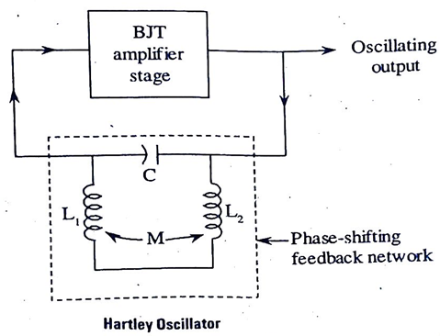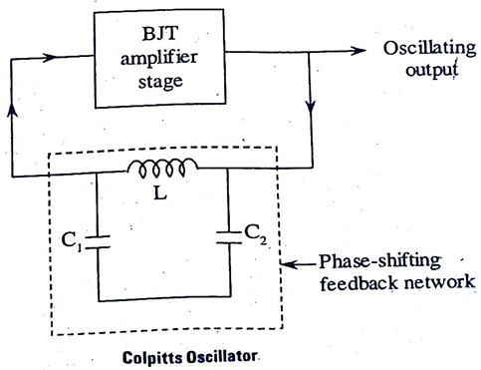

The circuit oscillates at resonant frequency of its phase shift network. Hence oscillating frequency

is equal to the resonant frequency which is given by

f = $\frac{1}{2π \sqrt{{L_{T }C}_{T }}}$*where $L_{T}$ = total inductance*

$C_{T}$*= total capacitance*

The phase shift network of Hartley oscillator consists of ***two inductors & one capacitor*** connected in π configuration whereas the phase shift network of Colpitts oscillator consists of ***one inductor & two capacitors*** connected in π configuration as shown above figure.

|  |
| --- |
| **2.2. STANDARD SIGNAL GENERATOR / RF SIGNAL GENERATOR** |

* A Standard signal produces known and controllable voltages.
* It is used as the power source for measurement of gain, SNR, BW, SWR and other properties.
* It is extensively used in the testing of the radio receivers and transmitters

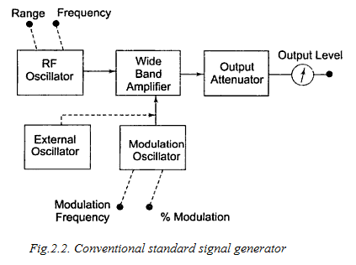

**Operation:**

1. The carrier signal (sine wave) is generated by stable RF oscillator using and LC tank circuit having constant output over any frequency range.
2. The carrier frequency can be modulated with sine / square / triangular wave (or) a pulse
3. The AM or FM signal can be obtained at the output of generator through a modulation circuit (external oscillator and modulation oscillator)
4. The modulated carrier is fed to output attenuator. Finally the level of o/p voltage can be read through output meter.

**Advantages:**

1. The output voltage can be controlled as per our requirement
2. Stable output

**Disadvantages:**

1. The frequency stability depends on the design of LC tank circuit of RF oscillator.

As frequency range switching is achieved through selection of appropriate capacitors,

the instrument require some time to stabilize at new resonant frequencies.

1. At high frequencies, it is essential to isolate the oscillator circuit from output circuit.

**Need for inserting isolation b/w oscillator circuit & output circuit:**

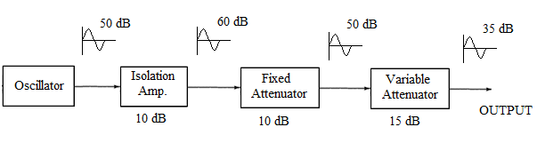

* 1. At high frequencies it is essential to isolate the oscillator circuit from output circuit.
  2. This isolation is necessary so that changes occurring in load do not affect the oscillator frequency, amplitude and distortion characteristics.
  3. Generally buffer amplifiers are used to isolate the oscillator circuit from output circuit at higher frequencies.
  4. The oscillator output is amplified by a certain amount using a buffer amplifier. Consequently it is attenuated by same amount by a fixed attenuator. In this way isolation is achieved without change in signal level of oscillator output.

|  |
| --- |
| **2.3. AF SINE & SQUARE WAVE GENERATOR** |

* As name indicates, it produces AF sine & square wave outputs.
* It employs Wien bridge oscillator. It is the best oscillator for audio frequency range.
* The function switch is used to connect the Wien bridge oscillator o/p to either sine wave amplifier or square wave shaper.
* The square wave shaper converts sinusoidal oscillations into square wave.
* The frequency of oscillations can be changed by varying capacitance (or) by switching in

resistors of different values.

f = $\frac{1}{2π \sqrt{R_{1}R_{2}C_{1}C_{2}}}$

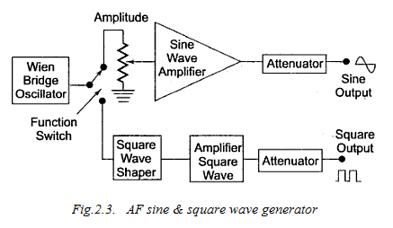

**Operation :**

*When the switch is connected to position 1*

The output of Wien bridge oscillator is connected to sine wave amplifier & then attenuator. The o/p is a pure sinusoidal & amplitude can be varied from 5 mV to 5 V (r ms).

*When the switch is connected to position 2*

The output of Wien bridge oscillator is connected to square wave shaper, which converts sinusoidal oscillations into square wave.

The square wave is amplified & then attenuated and finally appears as pure square wave whose amplitude can be varied from 0 V to 20 V (peak) with 30-70% duty cycle

**Specifications:**

Frequency range : 10Hz to 1MHz

Sine wave amplitude : 5 mV to 5 V (r ms)

Square wave amplitude : 0 V to 20 V (peak)

Duty cycle of square wave: 30% - 70 %

Power required : 7 W ( at 220V, 50Hz)

**The front panel of a signal generator consists of the following :**

1. ***Frequency selector*** : It selects the freq. in different ranges.

2. ***Freq. multiplier*** : It selects the frequency range over 5 decades from 10Hz to 1MHz.

10 Hz, 100 Hz, 1 KHz, 10 KHz, 100 KHz.

3. ***Amplitude multiplier*** : It attenuates the sine wave in 3 decades : x1, x0.1, x0.01.

4. ***Variable amplitude*** : It attenuates the sine wave continuously.

5. ***Symmetry control***  : It varies the symmetry of square wave from 30% to 70%.

6. ***Function switch*** : It selects either sine wave (or) square wave.

7. ***Sync*** : It provides synchronization of the internal signal with external signal. 8. ON/OFGF switch.

|  |
| --- |
| **2.4. FUNCTION GENERATOR** |

* A function generator produces different wave forms of adjustable frequency The common output wave forms are - Sine, Square, Triangular, Sawtooth waves
* The Frequency may be adjusted from a fraction of Hz to several KHz (0.01 Hz – 100 kHz)

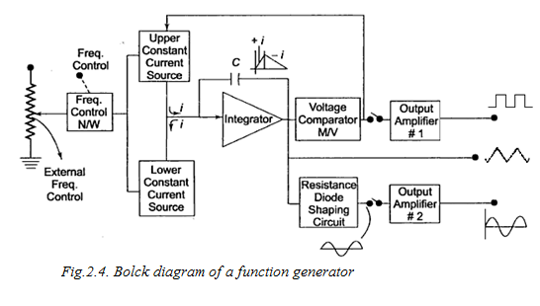

**Operation**:

1. Usually the frequency is controlled by using the capacitor in LC (or) RC circuit. In function

generator, the frequency is controlled by varying magnitude of current which drives integrator.

2. The frequency control network regulates two constant current sources :

***(i) The upper current source*** 🡪 supplies constant current to the integrator,

Now the output integrator e0 = =

since i & c are constants, the output of integrator e0 is a + ve going ramp signal.

Now the o/p of voltage comparator is HIGH.

When this o/p voltage reaches a pre-defined max.value,

the voltage comparator multivibrator changes the o/p state to LOW

and *lower current source* is connected to the integrator.

***(i) The lower current source*** 🡪 supplies a reverse current to the integrator

Hence the output of integrator e0 is a negative going ramp signal.

When this o/p voltage reaches a pre-defined min.value,

the voltage comparator multivibrator changes the o/p state to HIGH

and *upper current source* is connected to the integrator.

3. Hence the output integrator is triangular wave whose frequency depends on magnitude of

current supplied by constant current sources.

4. The output voltage comparator is a square wave of same frequency.

5. The resistance diode shaping circuit after the slope triangular wav as its amplitude changes and

produces a sine wave with less than 1% distortion.

|  |
| --- |
| **2.5. SQUARE & PULSE GENERATOR :** |

* The square & pulse generator along with CRO are used as measuring instruments.
* The fundamental difference b/w a pulse generator & square wave generator is in the duty cycle
* Duty cycle = pulse width/period.
* For a square wave, duty cycle = 50% (or) 0.5 (equal ON & OFF times)
* For a pulse, the duty cycle is less than 50% (or) greater than 50%.

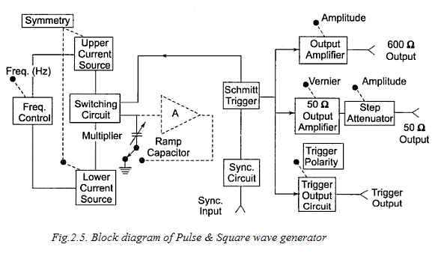

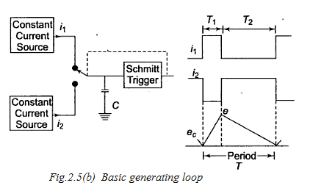

**Working/Operation:**

1. The basic generating loop consists of two current sources (UPPER & LOWER),

Ramp capacitor, Schmittt trigger and current switching ckt as shown in fig.2.5(b).

1. The UPPER current source provides constant current for charging the Ramp capacitor.

As ramp capacitor charge, the capacitor voltage increases linearly.

1. When +ve ramp voltage reached a pre-defined max.value, the Schmitt trigger changes the state & switch is connected to LOWER current source.
2. Now the capacitor discharger linearly, controlled by LOWER current source.
3. When the -ve ramp reaches a pre-defined min. value, the Schmitt trigger switcher back to its original state.
4. This now provides cuttings off lower current source &switching on upper current source.
5. This given one cycle of operation. The entire process is then repeated.
6. The ratio i1/i2 gives determines the duty cycle & is controlled by symmetry control.

The sum (i1 + i2) determines the frequency.

**Features**:

1. The frequency range : 1 HZ to 10 MHZ
2. Duty Cycle : 25% to 75%
3. Two independent outputs are available

(i) 600 Ω Square supplies pulse with rise and fall time of 70ns at 30V peak Amplitude.

(ii) 50Ω source supplies pulses with rises and fall time of 5ns at peak amplitude.

1. It can be operated as the free running generator (or)

it can be synchronized with external signals.

1. The trigger output pulses are also available. (trigger o/p ckt consists of differentiator ckt)

|  |
| --- |
| **2.6. STANDARD SWEEP GENERATOR :** |

It provides a sinusoidal o/p voltage whose frequency varies smoothly and continuously over an entire frequency band, usually at an audio rate.

*( Time base generators generate sweep waveform also called as Ramp (or)saw tooth waveform.*

*Most of the CRO applications involve measurement (or)display of a quantity which varies with time.*

*This requires that CRT spot moves across the screen with a constant velocity. For this purpose, the sweep voltage is applied to a set of deflection plates so that the election beam moves across the screen).*

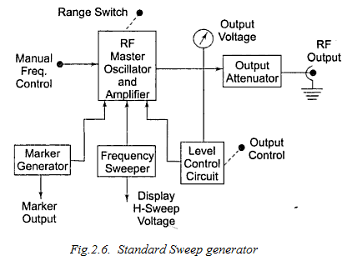

1. Sweep generators generally sweep in frequency in a linear manner, but may also offer a logarithm frequency sweep.
2. The frequency sweeper provides a variable modulating voltage, which causes the capacitance of master oscillator to vary.
3. The approximate value of sweep rate is around 20 sweeps/sec.
4. The frequency sweeper also provides a varying sweep voltage single to horizontal deflection plates of CRO.
5. The ramp signal is applied to Voltage Tuned Oscillator (VTO). The o/p frequency of VTO sweeps from low to high frequency as ramp voltage increases from zero to final value.
6. To identify a frequency interval, a marker generator provides half sinusoidal signal to the oscillator at any range of frequency within the sweep range.

Also, the o/p of marker is combined with the sweep voltage of the CRO at alternate cycle of the sweep. Therefore, it appears super imposed on the o/p wave.

1. The manual frequency control🡪 permits to adjust the resonant freq. of RF oscillator.
2. The level control ckt🡪 (i) monitors the RF level at some point in the measurement system.

(ii) It maintains the power delivered to the load at constant &

independent of variations in impedance & frequency.

|  |
| --- |
| **2.7. RANDOM NOISE GENERATOR :** |

Random noise generator generates an output signal whose amplitude changes randomly & doesn’t contain any periodic frequency components. A simplified block diagram used in the audio frequency range is shown in figure.

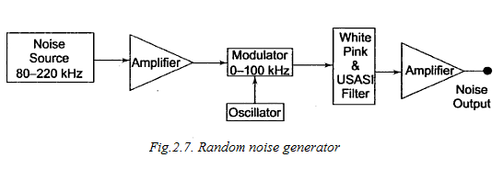

1. This instrument offers the possibility of using a single measurement to indicate performance over a wide frequency band.
2. The noise source can be a semi conductor noise diode, which delivers noise frequencies in the range 80Hz to 220KHz.
3. The o/p from noise diode is amplified and applied to balanced symmetrical modulator, where it is mixed down to the band of audio frequencies.
4. The filter arrangement controls the bandwidth and supplies the output signal in

3-spectrum choices: WHITE noise, PINK noise, USASI noise.

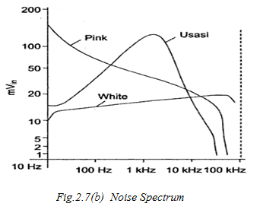

(i) ***White noise***: Covers all frequencies as it has equal power spectral density.

(ii) ***Pink noise***: Has a spectrum same as that of Red light.

It has larger amplitudes at low freq ranges.

It has a voltage spectrum which is inversely proportional to $\sqrt{freq.}$

(iii) **USASI noise**: Similar to energy distribution of speech & music frequencies.

It is used for testing audio amplifiers & loud speakers.

|  |
| --- |
| **2.8. ARBITRARY WAVEFORM GENERATOR :** |

* Arbitrary wave form doesn’t have a particular pre defined shape (or) characteristics.
* The amplitude (or) frequency of an arbitrary wave form vary in a random manner.
* An arbitrary wave form may be periodic (or) non periodic. It may also include transients,

noise components etc.

* Arbitrary wave forms are used as test signals to determine whether the test equipment is functioning properly & also to detect any faults present in the equipment.

A

LPF

D/A convertor

RAM

Address counter

/p o/p

Clock

1. The arbitrary wave form generator produces the wave forms based on digital data stored in RAM. This digital data gives the detain information of desired wave form.
2. The digital data samples stored in RAM represent the desired waveform. These samples are applied to the D/A converter.
3. The D/A converter produces a voltage proportional to the digital data supplied to it.
4. The address counter is incremented for every clock pulse applied.
5. Since the DAC produces stair case output for a set of input samples, the LPF is used for smoothening the DAC output by removing high frequency components.
6. **According to sampling theorem, the sampling should be done at** Nyquist rate to preserve the information of the signal.

i.e., from sampling theorem, *fs = 2fm*

*where fs = sampling frequency*

*fm = Max. freq. component of the signal*.